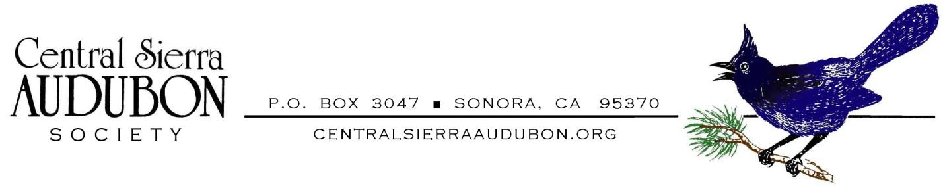
Central Sierra Audubon Membership Form
(Please Print)
Name _______________________________________
email _______________________________________
Mailing Address ________________________________________________________________

⬜ New or Renewing Central Sierra Audubon Society Annual Membership.
Make your Check Payable to CSAS for $15.00 / year. THANK YOU !
⬜ I just want to receive the monthly newsletter without becoming a voting member - $0.00
⬜ Yes, I want to help, check all that apply.
⬜ Christmas Bird Counts
⬜ Outreach to the Community – School Programs, Scholarship Program
⬜ Construction, Monitoring and Upkeep of Nesting Boxes
⬜ Participate in Field Trips
⬜ Can help with social media (Facebook, Website, Newsletter, Technology)
⬜ Other ____________________________________________
Mail to: CSAS Membership
P.O. Box 3047
Sonora, CA 95370
If you wish to become a member of the National Audubon Society and receive their monthly magazine, or to renew an existing membership, please do so on-line at:
• New Member: https://act.audubon.org/a/donate-search-become-annual-1?ms=digital-fund-ppc-google-membership-join-annual-20240000&gad_source=1&gclid=CjwKCAjwrIixBhBbEiwACEqDJdAlbU5bRFSlrcJBCp1RJu5BsmRsjG85hDbiDp2fiFUY9P12ndtXahoCeG8QAvD_BwE
• Renewal: https://act.audubon.org/a/donate-search-renew-annual

